# **TEAM APACHE GROOVY**

# **API Documentation**

Ganesh Kumar Rajasekar - G37969806

Prudhvi Lakshmi Sesha Sai Cheedella - G22981341

Sai Nikhil Varada – G43353336

Yashwanth Raj Varadharajan - G47635180

**CLIENT SIDE APIs**

**NEW USER REGISTRATION**

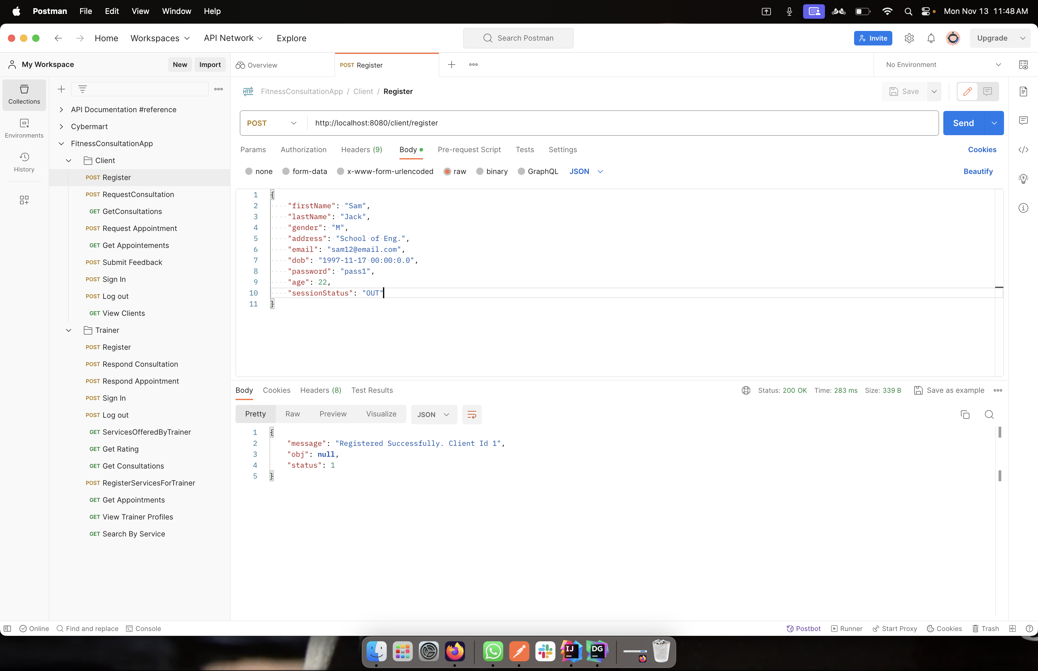

This API takes in values like Name, gender, address, email, dob, password and age. Once all the information are entered, the user is given a client ID and all the values are stored in Database.

**Method:** POST

**URL:** http://localhost:8080/client/register

**Request:**

{

"firstName": "Sam",

"lastName": "Jack",

"gender": "M",

"address": "School of Eng.",

"email": "sam12@email.com",

"dob": "1997-11-17 00:00:0.0",

"password": "pass1",

"age": 22,

"sessionStatus": "OUT"

}

**Response:**

* **Successful –** Status ->1

Message->Registered Successfully {Client Id created}

* **Error –** Status -> 0

Message -> Registration Failed

**LOGIN**

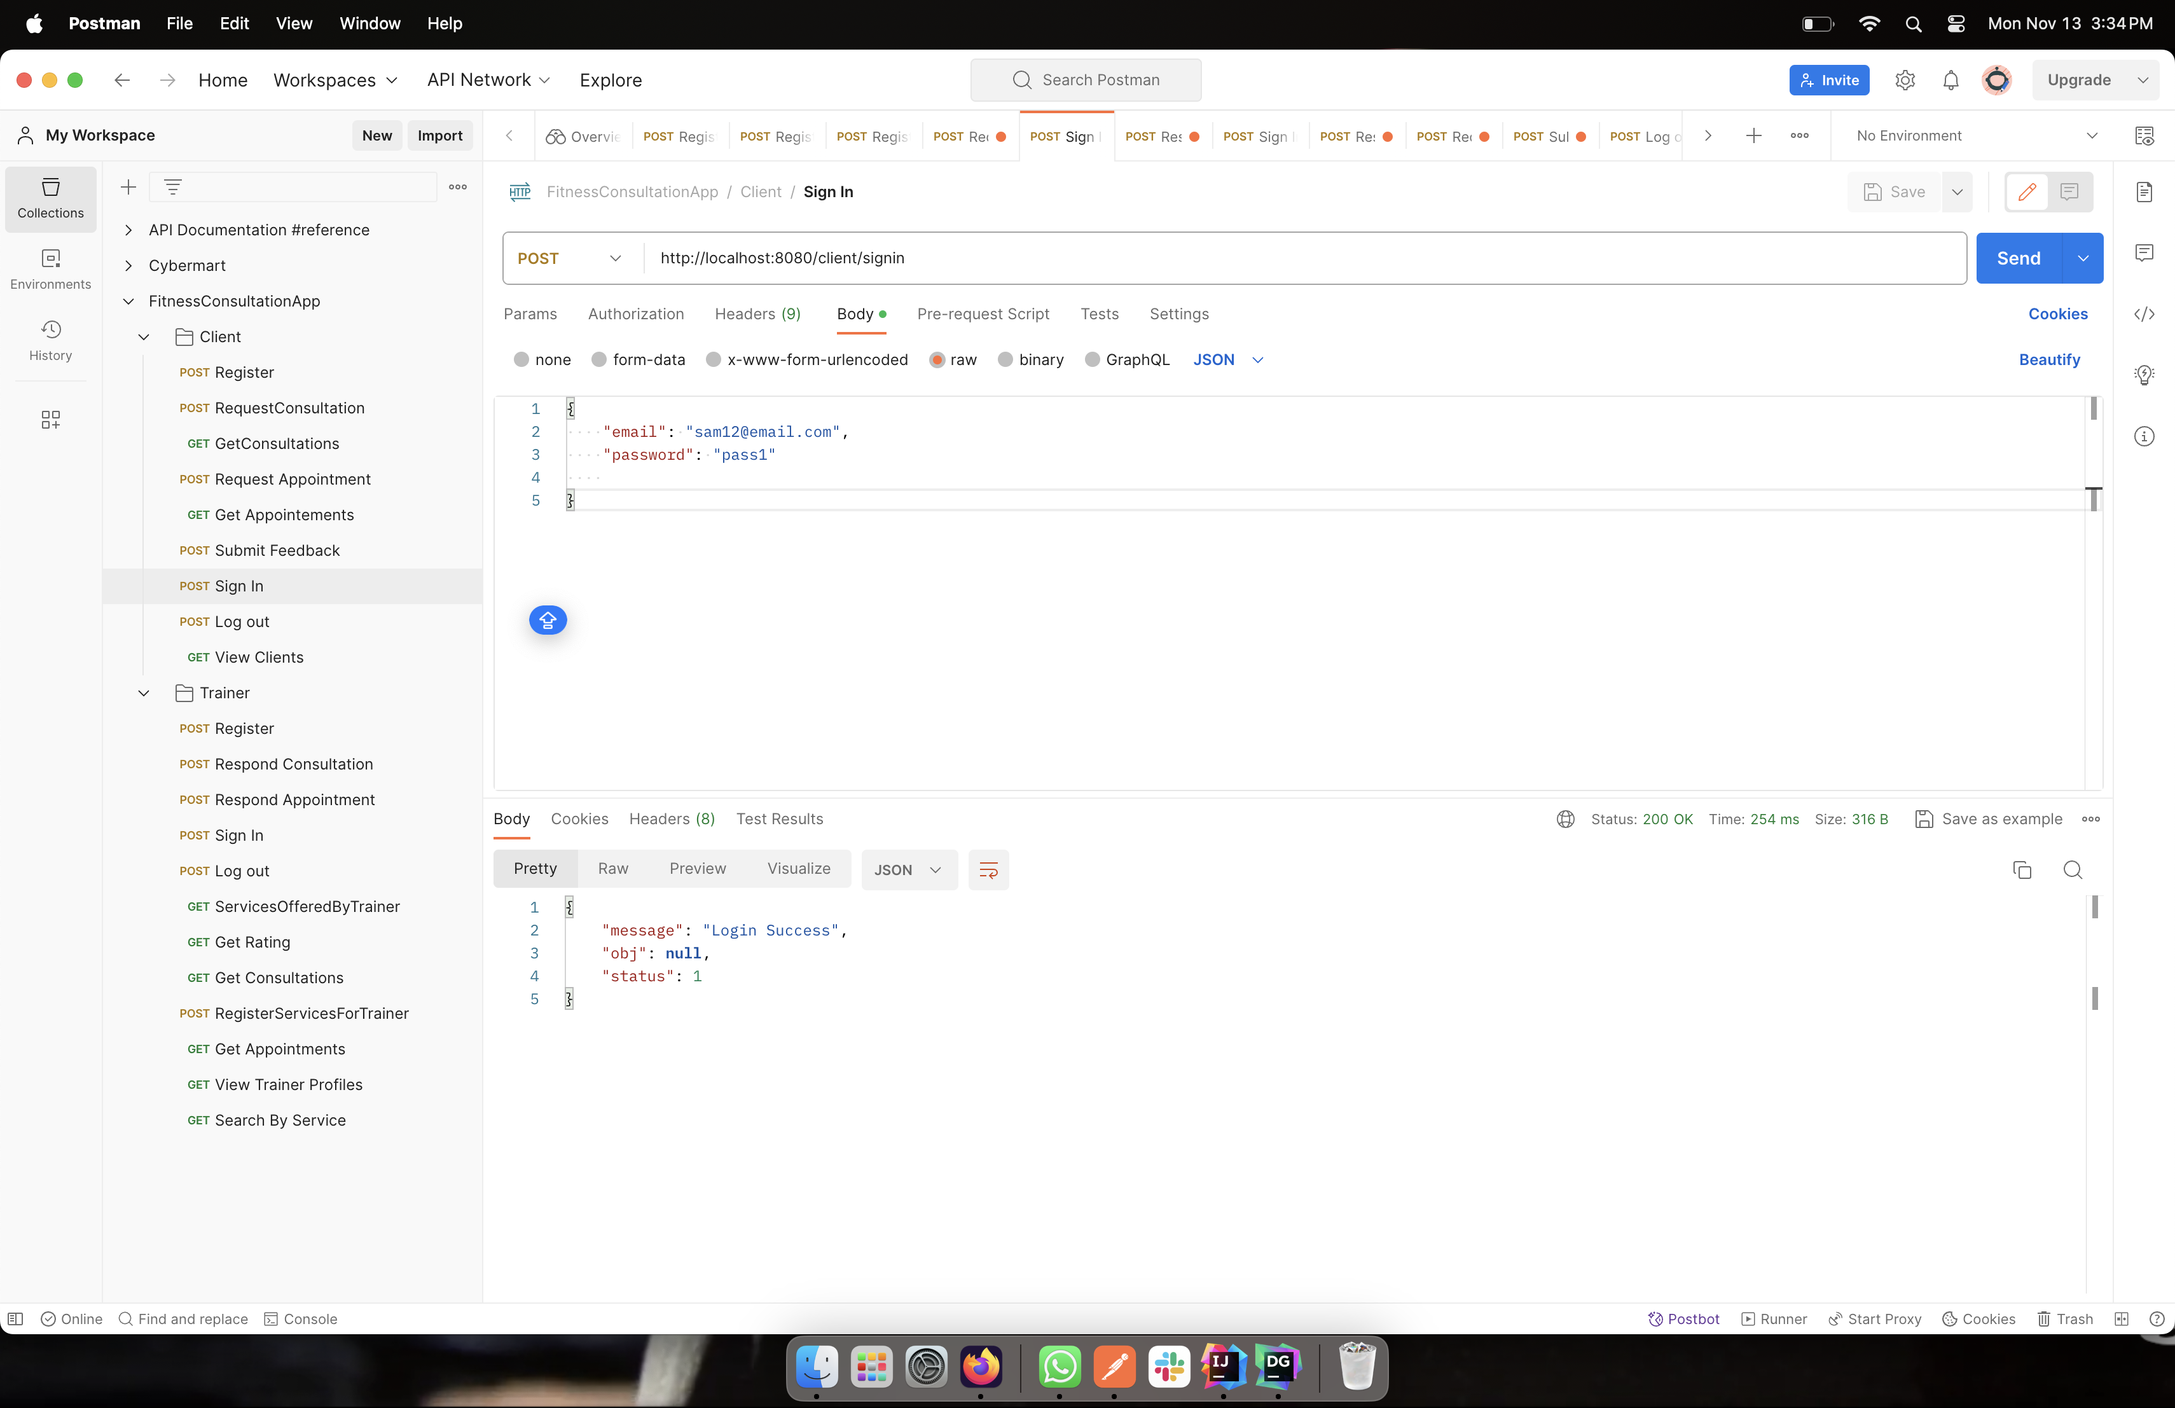

The user enters the given username and password to enter the portal. Once login details are entered correctly, the message “Login Success” appears, and session status is changed to IN.

**Method:** POST

**URL:** http://localhost:8080/client/signin

**Request:**

{

"email": "sam12@email.com",

"password": "pass1"

}

**Response:**

* **Successful –** Status ->1

Message-**>** Login Success

* **Error –** Status -> 0

Message -> Incorrect Password

-> No client present with given emailId

**VIEW PROFILE**

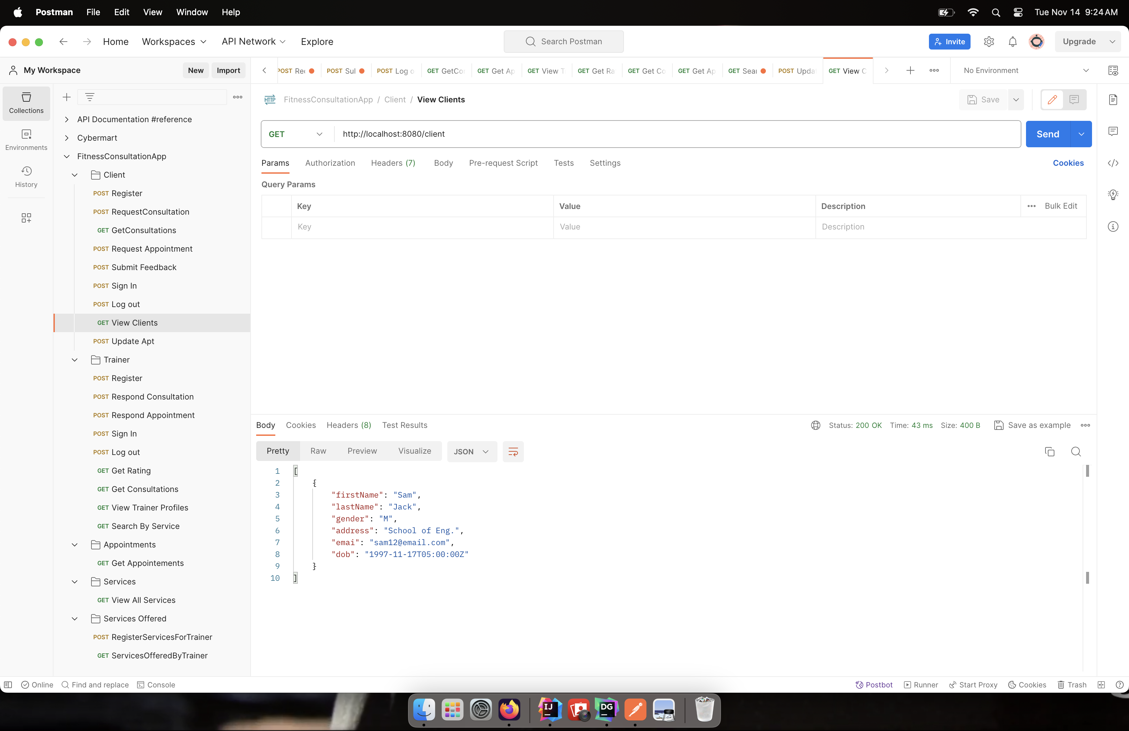

This API enables users to view their profile information. The client ID is looked up in the database and all the information stored is displayed.

**Method:** GET

**URL:** http://localhost:8080/client

**Request:**

clientId

format

**Response:**

* **Successful –** Status ->1

Message-> Success

* **Error –** Status -> 0

Message -> No Client present with given clientId

-> Provide a valid clientId

**CLIENT REQUEST CONSULTATION**

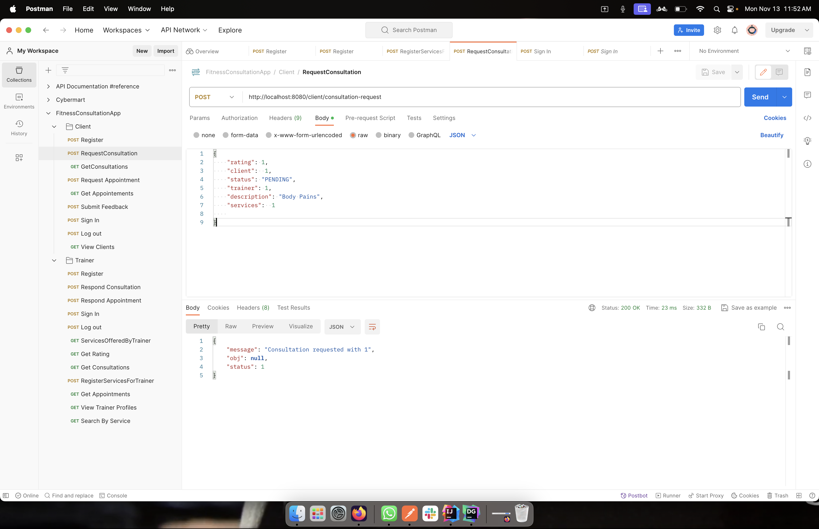

The client can send a consultation request once they have viewed and chosen the service and trainer. This request is sent to the trainer with the service ID and service description.

**Method:** POST

**URL:** http://localhost:8080/client/consultation-request

**Request:**

{

"rating": 1,

"client": 1,

"status": "PENDING",

"trainer": 1,

"description": "Dietary Requirements 1",

"services": 1

}

**Response:**

* **Successful –** Status ->1

Message-> Consultation requested with {consultation.id}

* **Error –** Status -> 0

Message -> Client of this consultation must be signed in to use this API

**VIEW CONSULTATION DETAILS**

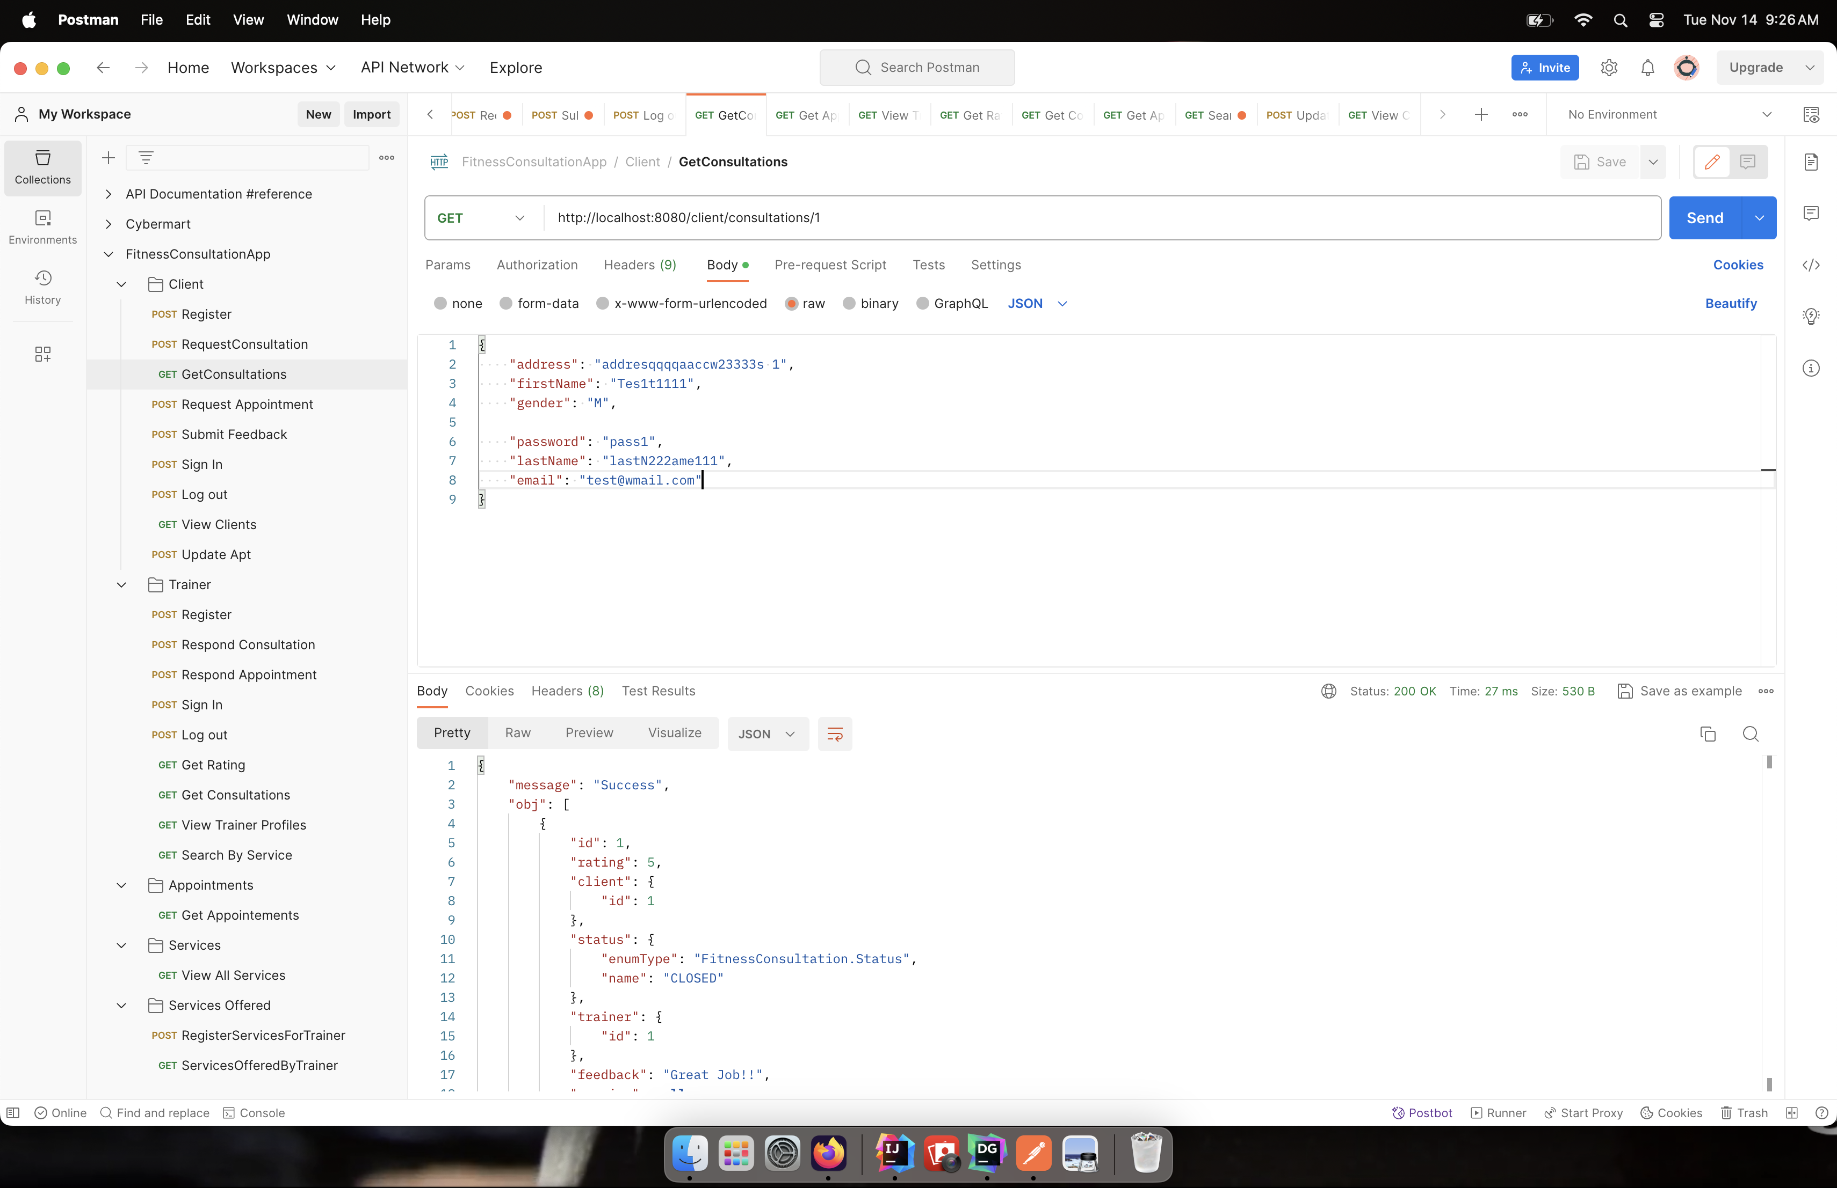

The users can view the consultation details of the requested. This is referenced with the trainer and consultation ID.

**Method:** GET

**URL:** http://localhost:8080/client/consultations/1

**Request:**

{

"address": "addresqqqqaaccw23333s 1",

"firstName": "Tes1t1111",

"gender": "M",

"password": "pass1",

"lastName": "lastN222ame111",

"email": "test@wmail.com"

}

**Response:**

* **Successful –** Status ->1

Message-> Success

* **Error –** Status -> 0

Message -> No Consultation Present with the given consultationId

-> Provide a valid consultationId

**CLIENT REQUEST APPOINTMENT**

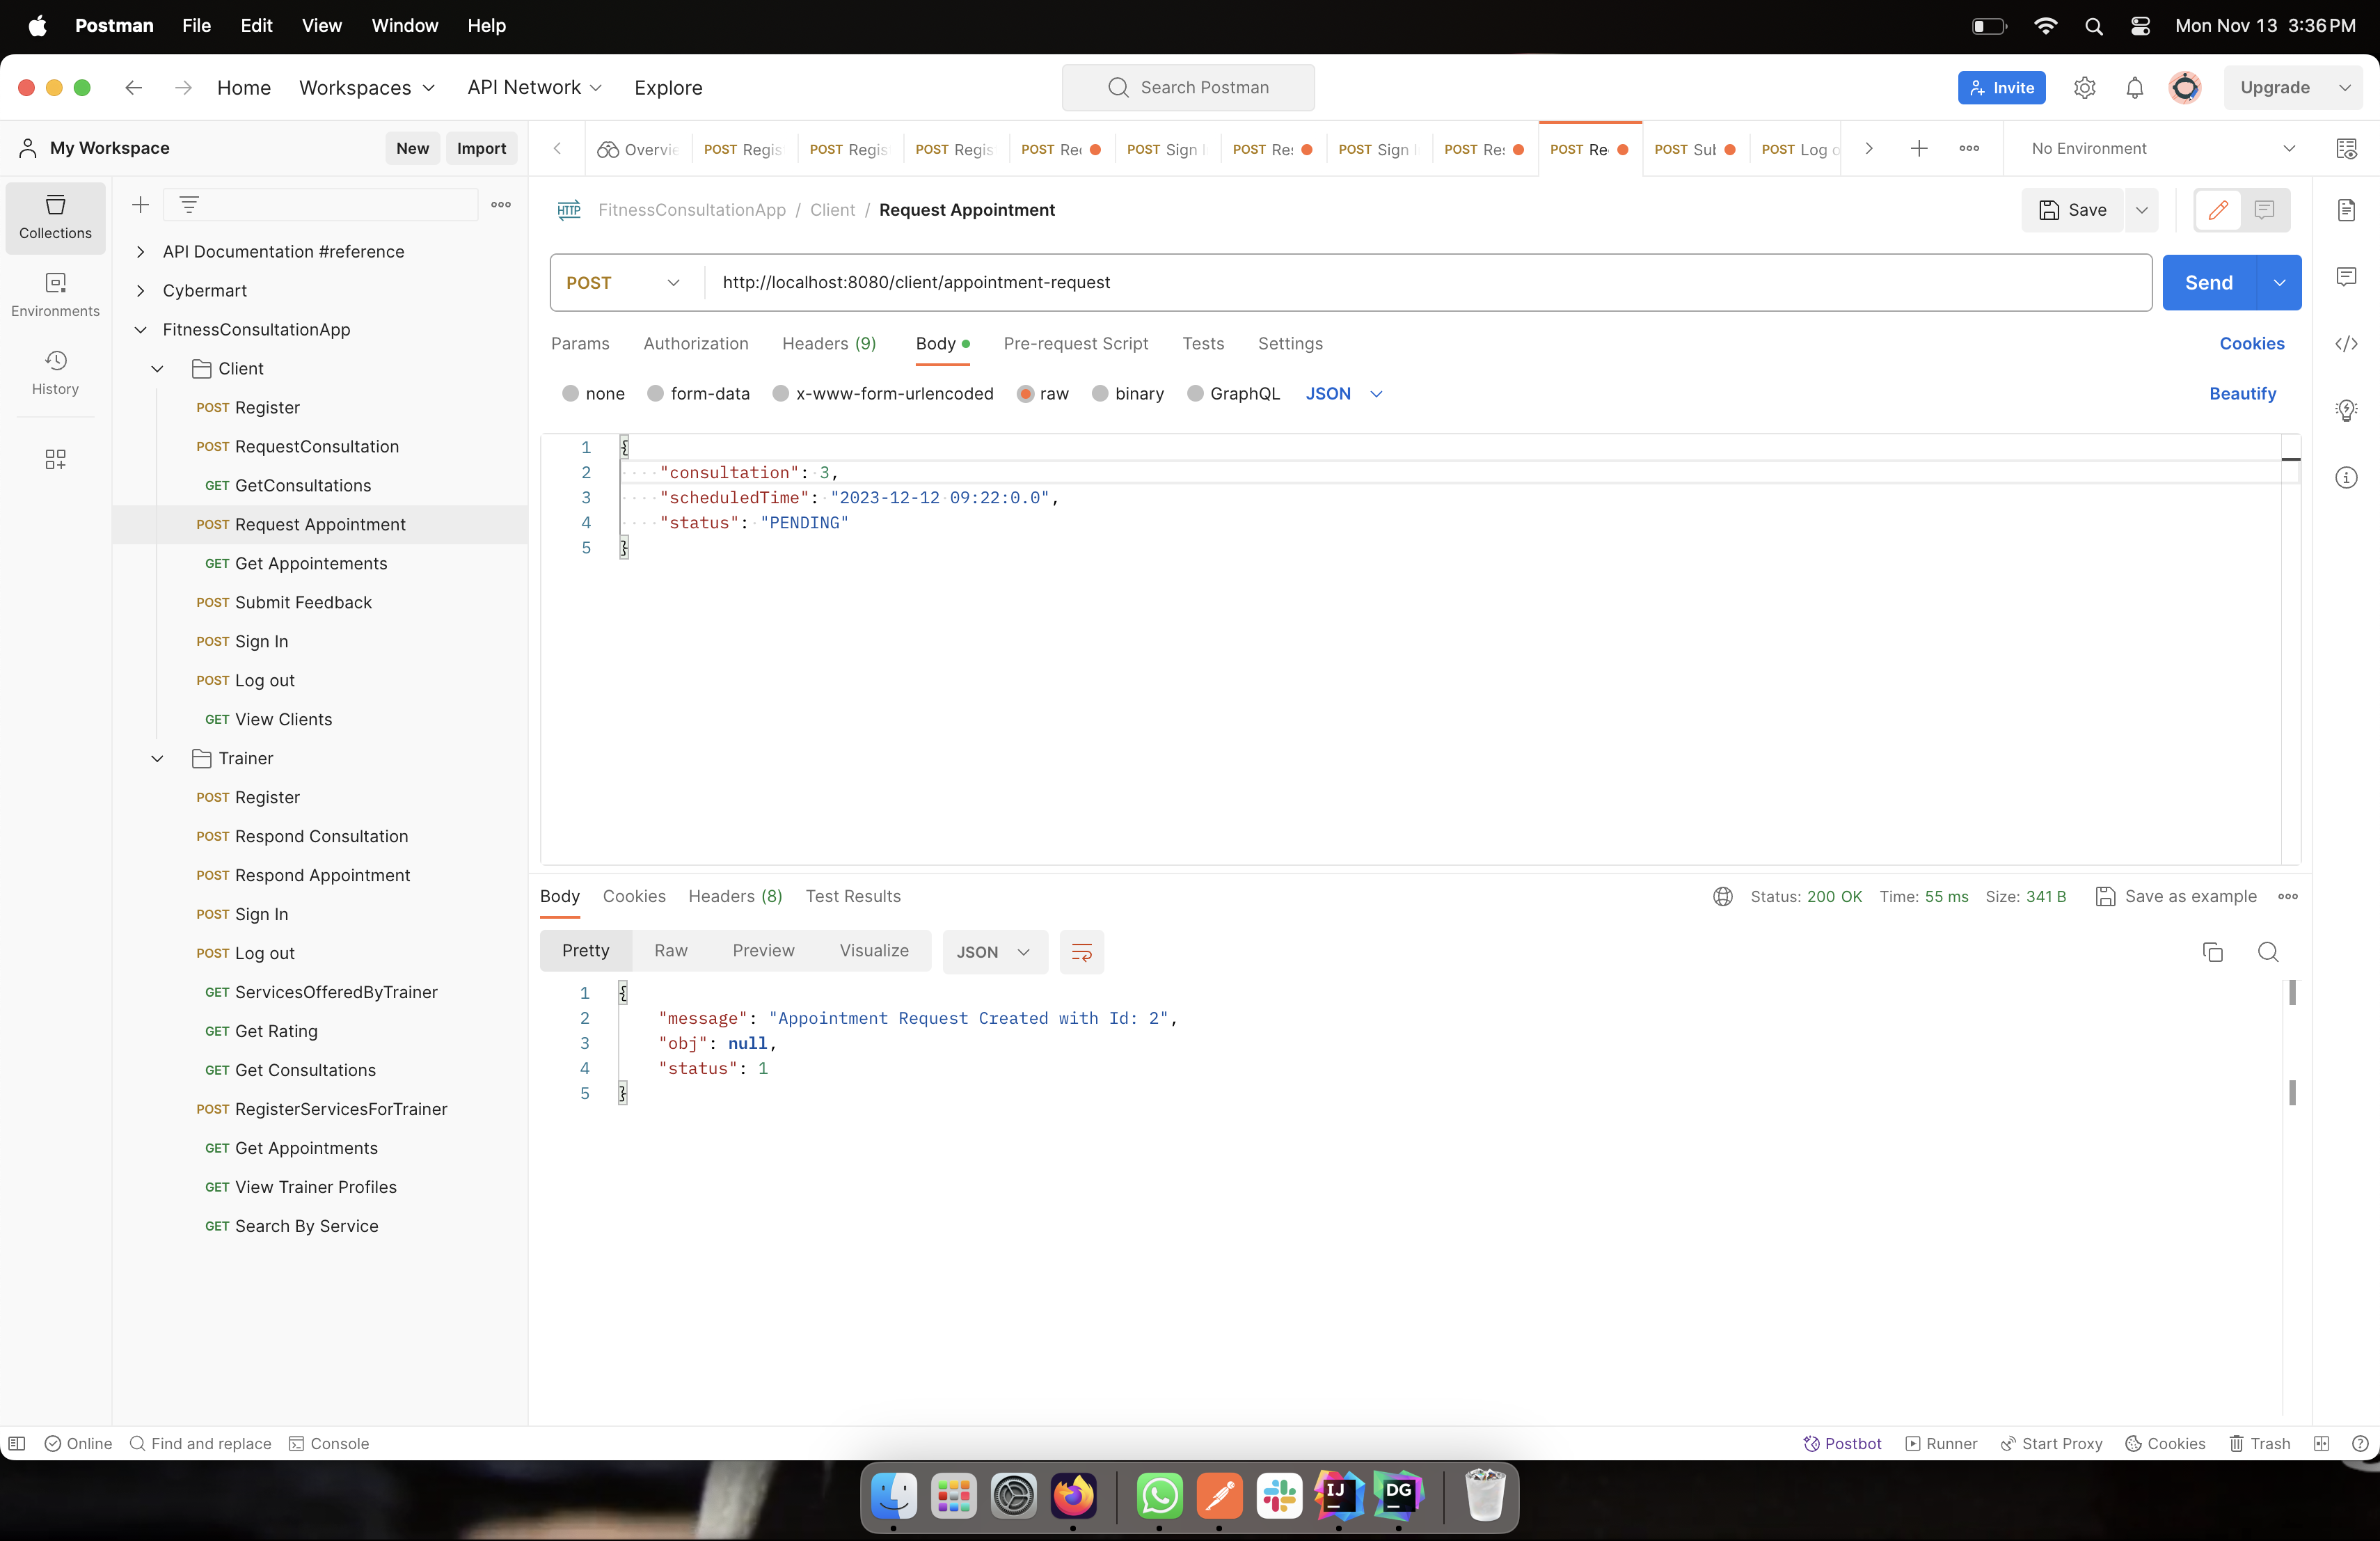

Once the trainer has accepted the consultation request, the clients can send the appointment request with date and time mentioned. The API will accept date and time that is greater than current. Now the appointment request goes to trainer to respond.

**Method:** POST

**URL:** http://localhost:8080/client/appointment-request

**Request:**

{

"consultation": 1,

"scheduledTime": "2023-11-15 09:22:0.0",

"status": "PENDING"

}

**Response:**

* **Successful –** Status ->1

Message-> Appointment Request Created

* **Error –** Status -> 0

Message -> Consultation Must Be Accepted By the trainer first

-> Client of this appointment must be signed in to use this API

**UPDATE APPOINTMENT**

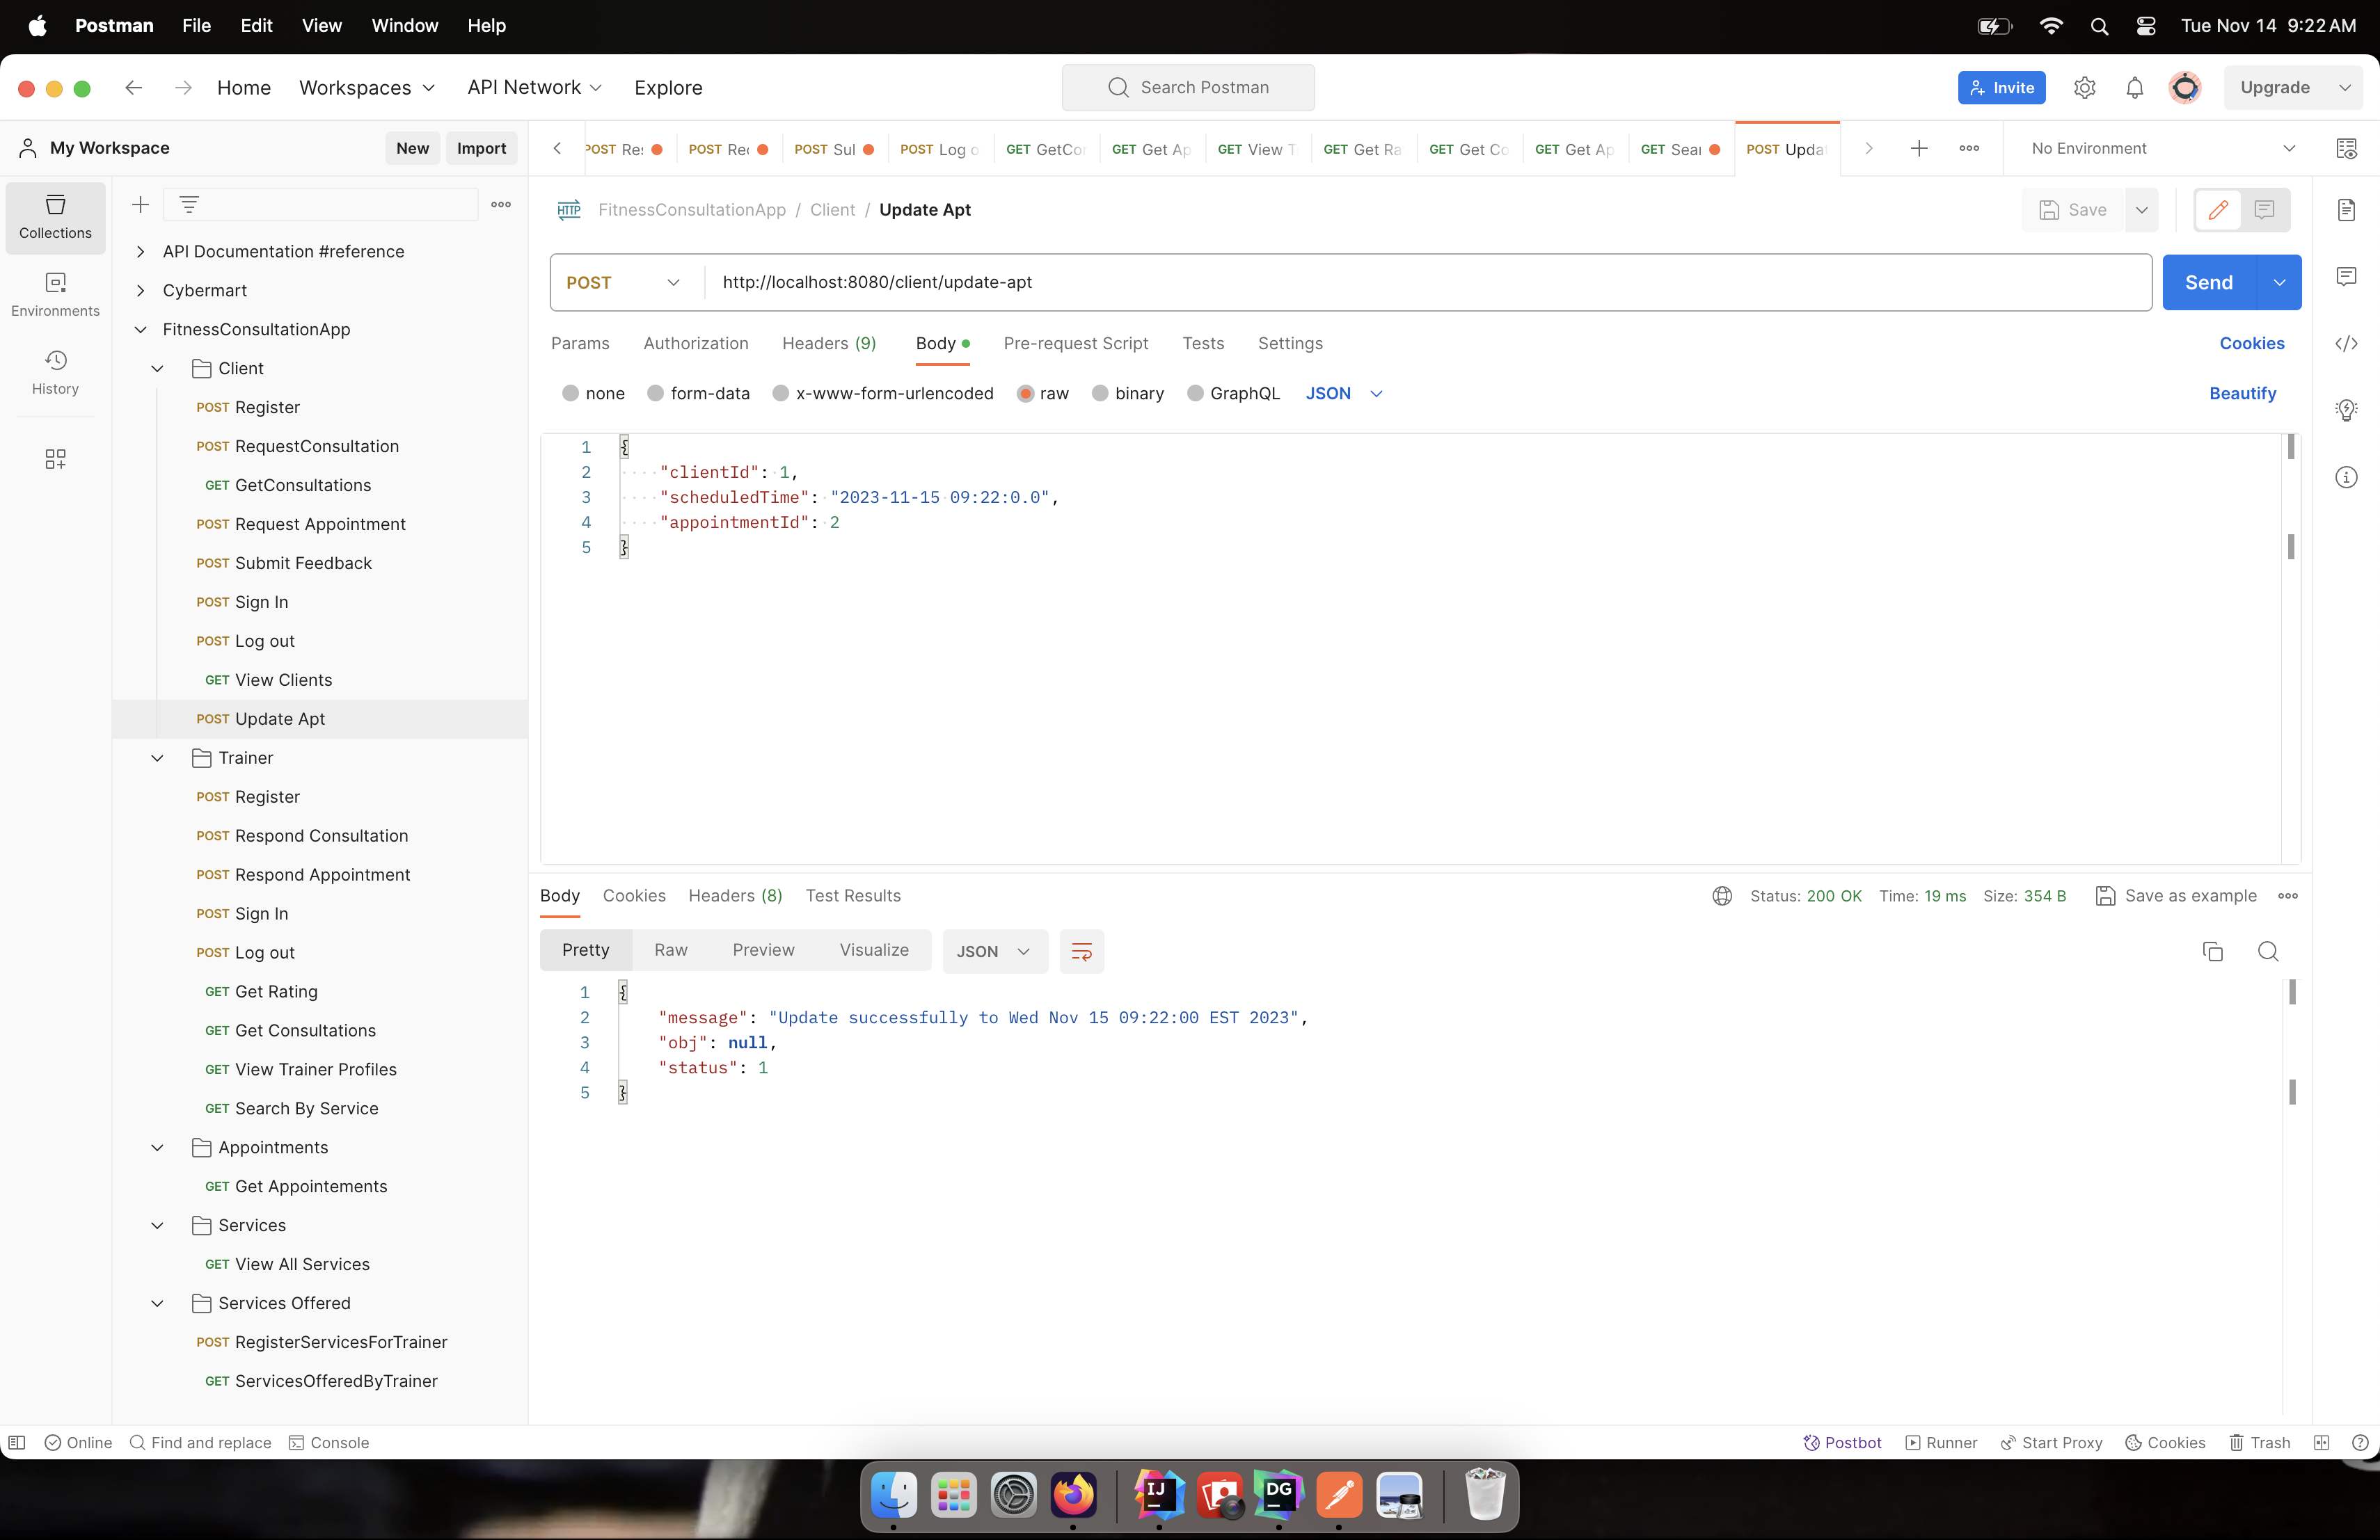

With reference with the appointment ID, clients can change and update the date and time accordingly.

**Method:** POST

**URL:** http://localhost:8080/client/update-apt

**Request:**

{

"clientId": 1,

"scheduledTime": "2023-11-15 09:22:0.0",

"appointmentId": 2

}

**Response:**

* **Successful –** Status ->1

Message-> Update Appointment

* **Error –** Status -> 0

Message -> Date and Time must be different from previous appointment

-> No Consultation Present with the given consultationId

**FEEDBACK**

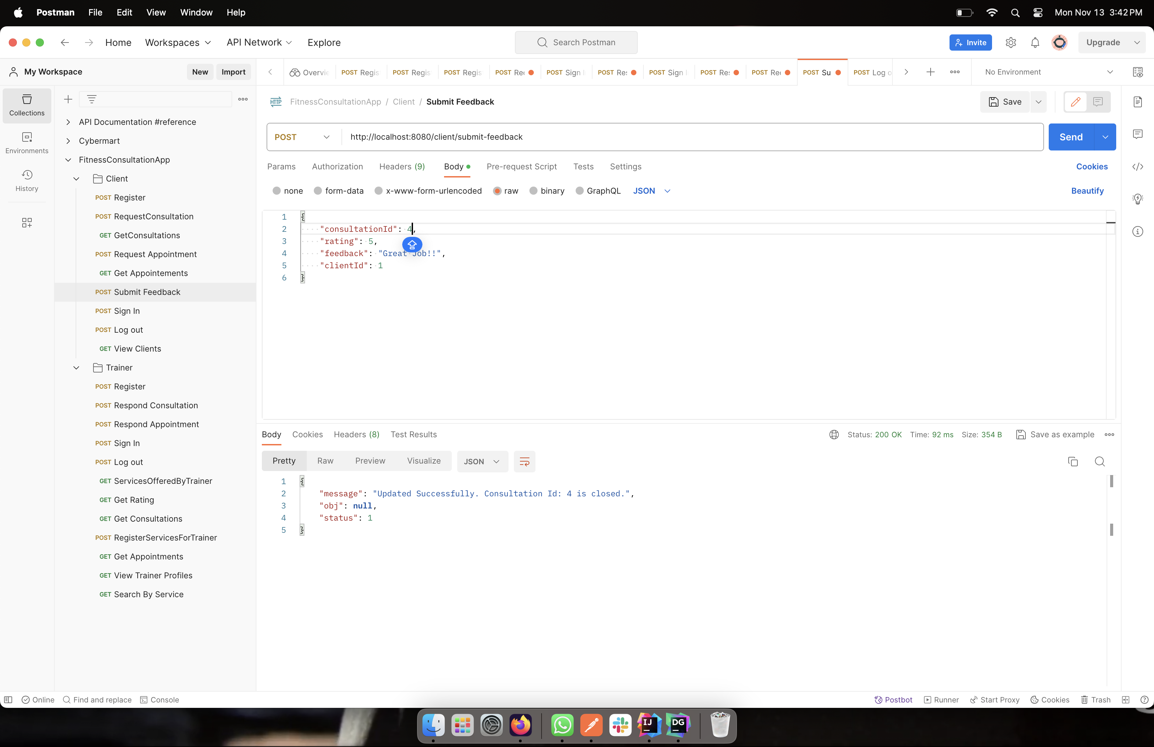

Once the service is completed, the users can submit feedback about the trainer and service. Once this is done, the referenced consultation ID, the status changes to closed.

**Method:** POST

**URL:** http://localhost:8080/client/submit-feedback

**Request:**

{

"consultationId": 1,

"rating": 5,

"feedback": "Great Job!!",

"clientId": 1

}

**Response:**

* **Successful –** Status ->1

Message-> Updated Successfully

* **Error –** Status -> 0

Message -> There still pending appointments. Please finish them first before submitting feedback

-> No accepted appointments available to submit feedback

-> Status of given consultation {consultation.status - reject}

-> Client must be signed in to use this API

**LOG OUT**

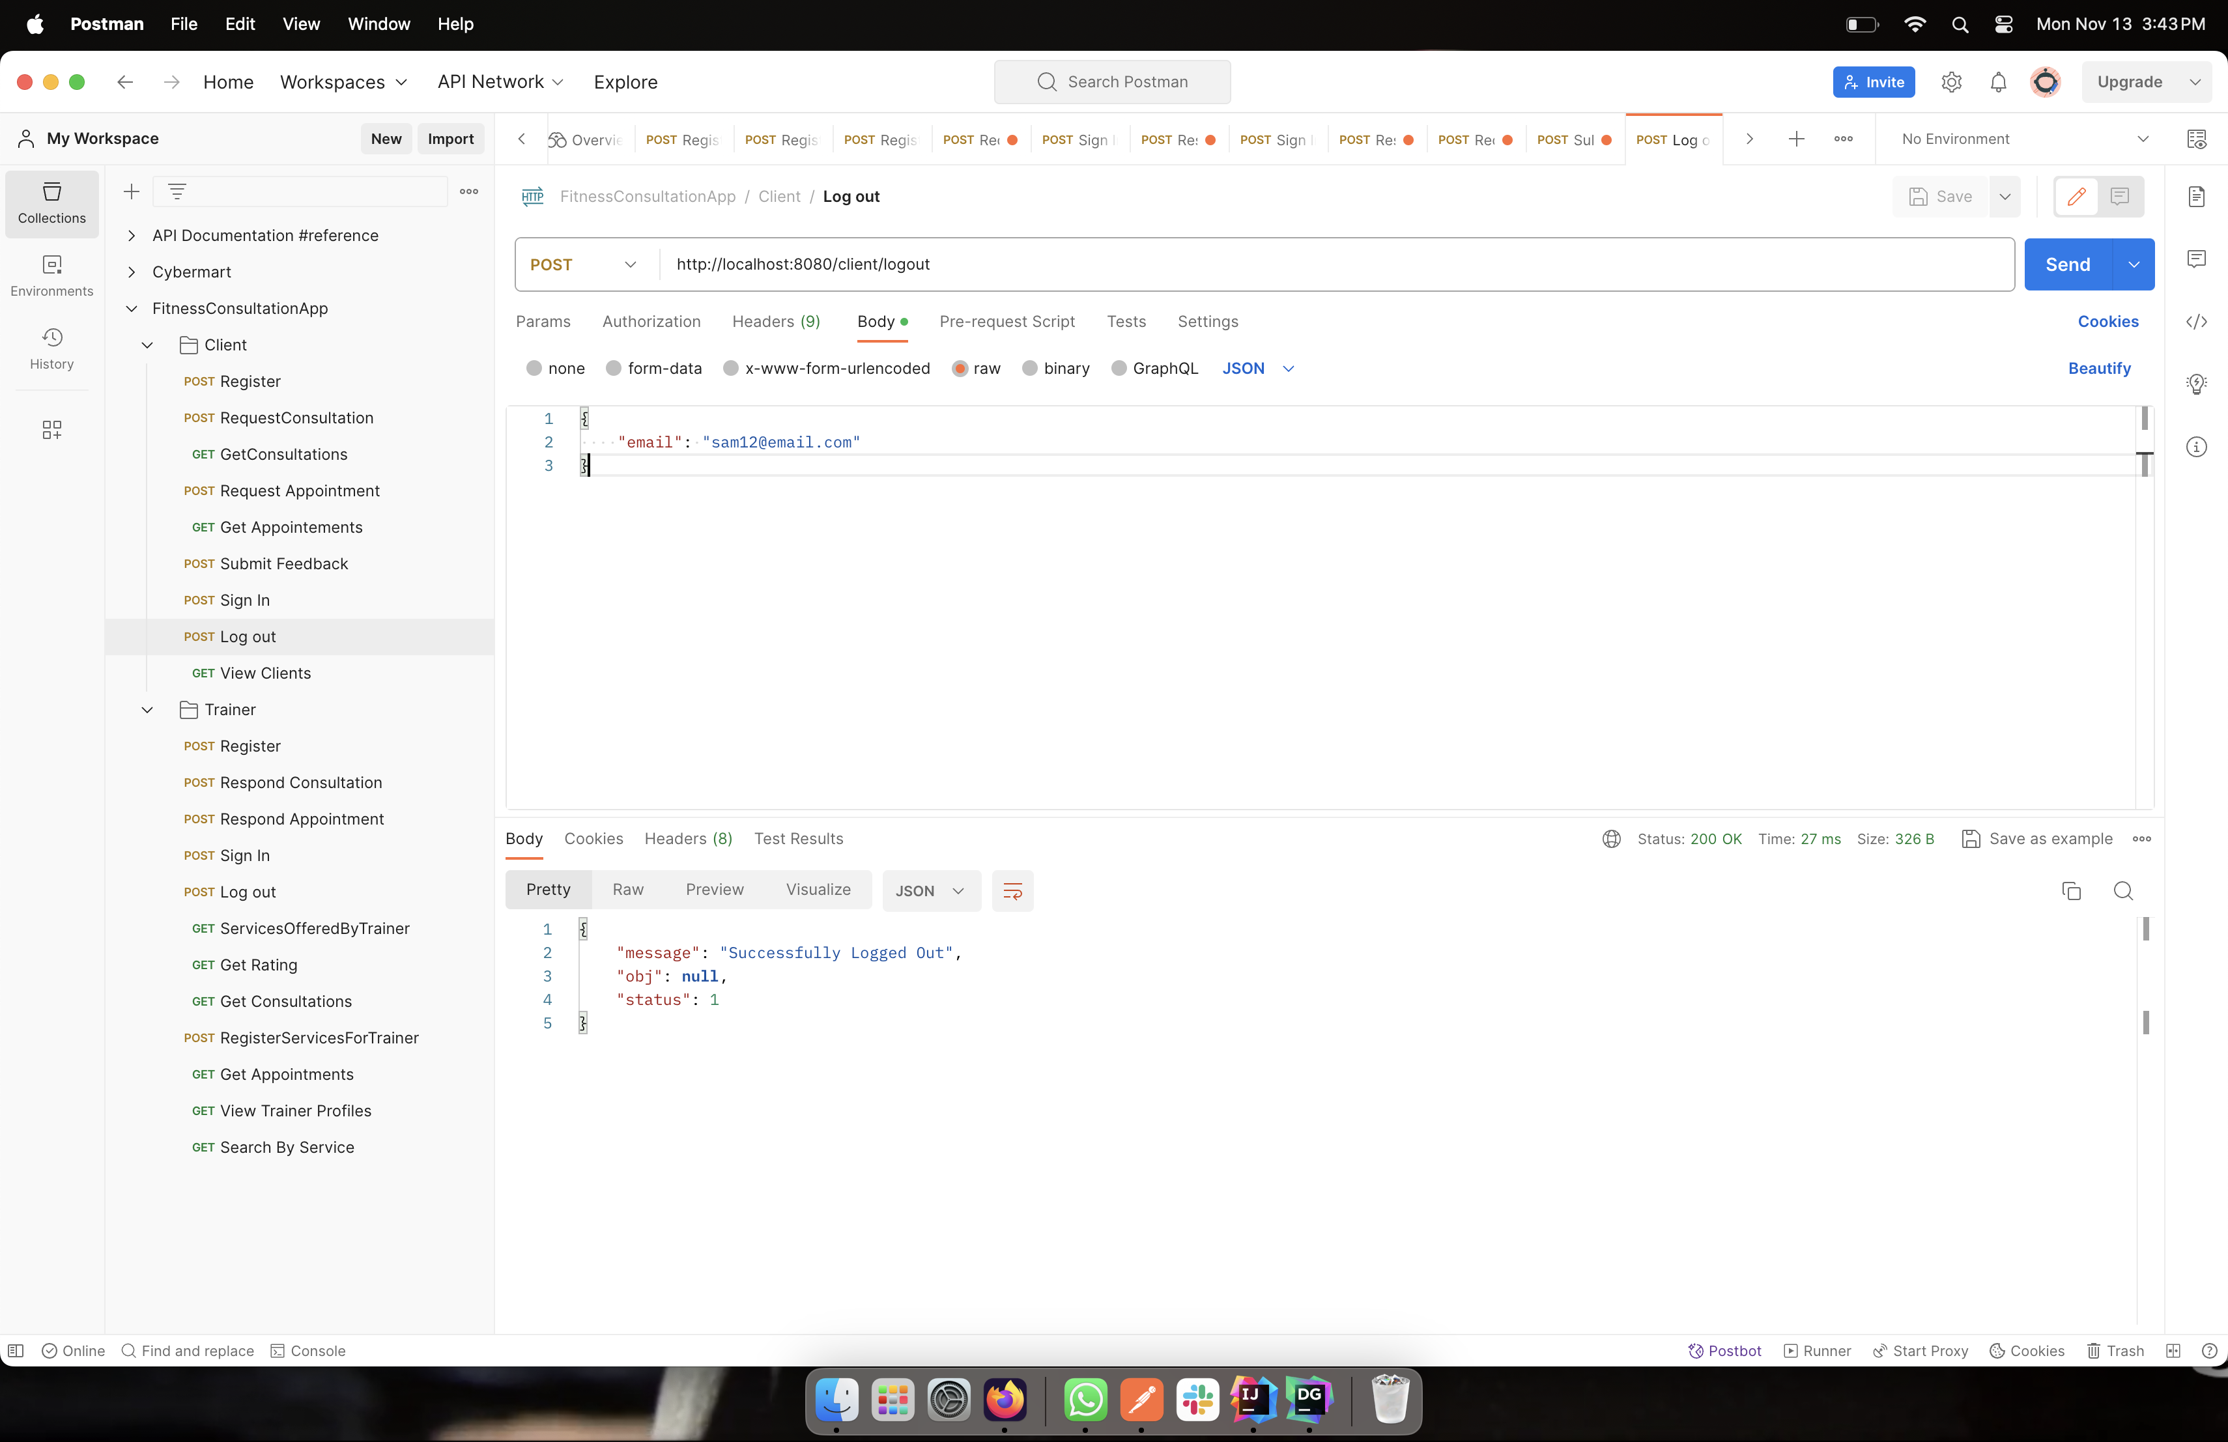

Once the services are utilized, users can logout from the systems.

**Method:** POST

**URL:** http://localhost:8080/client/logout

**Request:**

{

"email": "sam12@email.com"

}

**Response:**

* **Successful –** Status ->1

Message-> Successfully Logged Out

* **Error –** Status -> 0

Message -> Incorrect email

-> No client present with given emailId

**TRAINER SIDE APIS**

**NEW USER REGISTRATION**

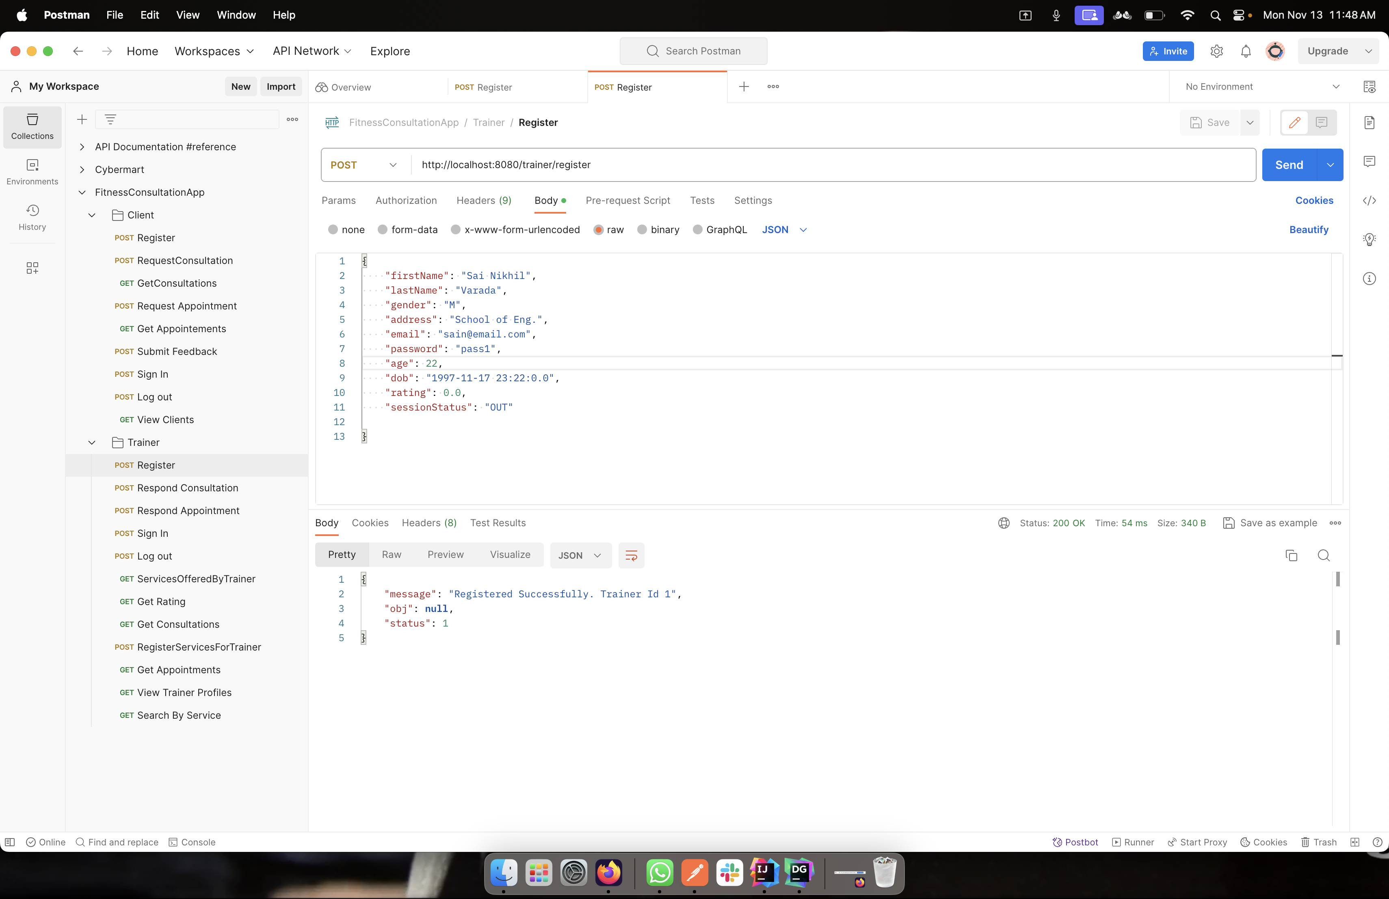

This API takes in values like Name, gender, address, email, dob, password and age. In addition, there is another field called rating, which has a default value of zero for new trainers. Once all the information are entered, the user is given a Trainer ID and all the values are stored in Database.

**Method:** POST

**URL:** http://localhost:8080/trainer/register

**Request:**

{

"firstName": "Sai Nikhil",

"lastName": "Varada",

"gender": "M",

"address": "School of Eng.",

"email": "sain@email.com",

"password": "pass1",

"age": 22,

"dob": "1997-11-17 23:22:0.0",

"rating": 0.0,

"sessionStatus": "OUT"

}

**Response:**

* **Successful –** Status ->1

Message-> Registered Successfully {TrainerID created}

* **Error –** Status -> 0

Message -> Registration Error

**LOGIN**

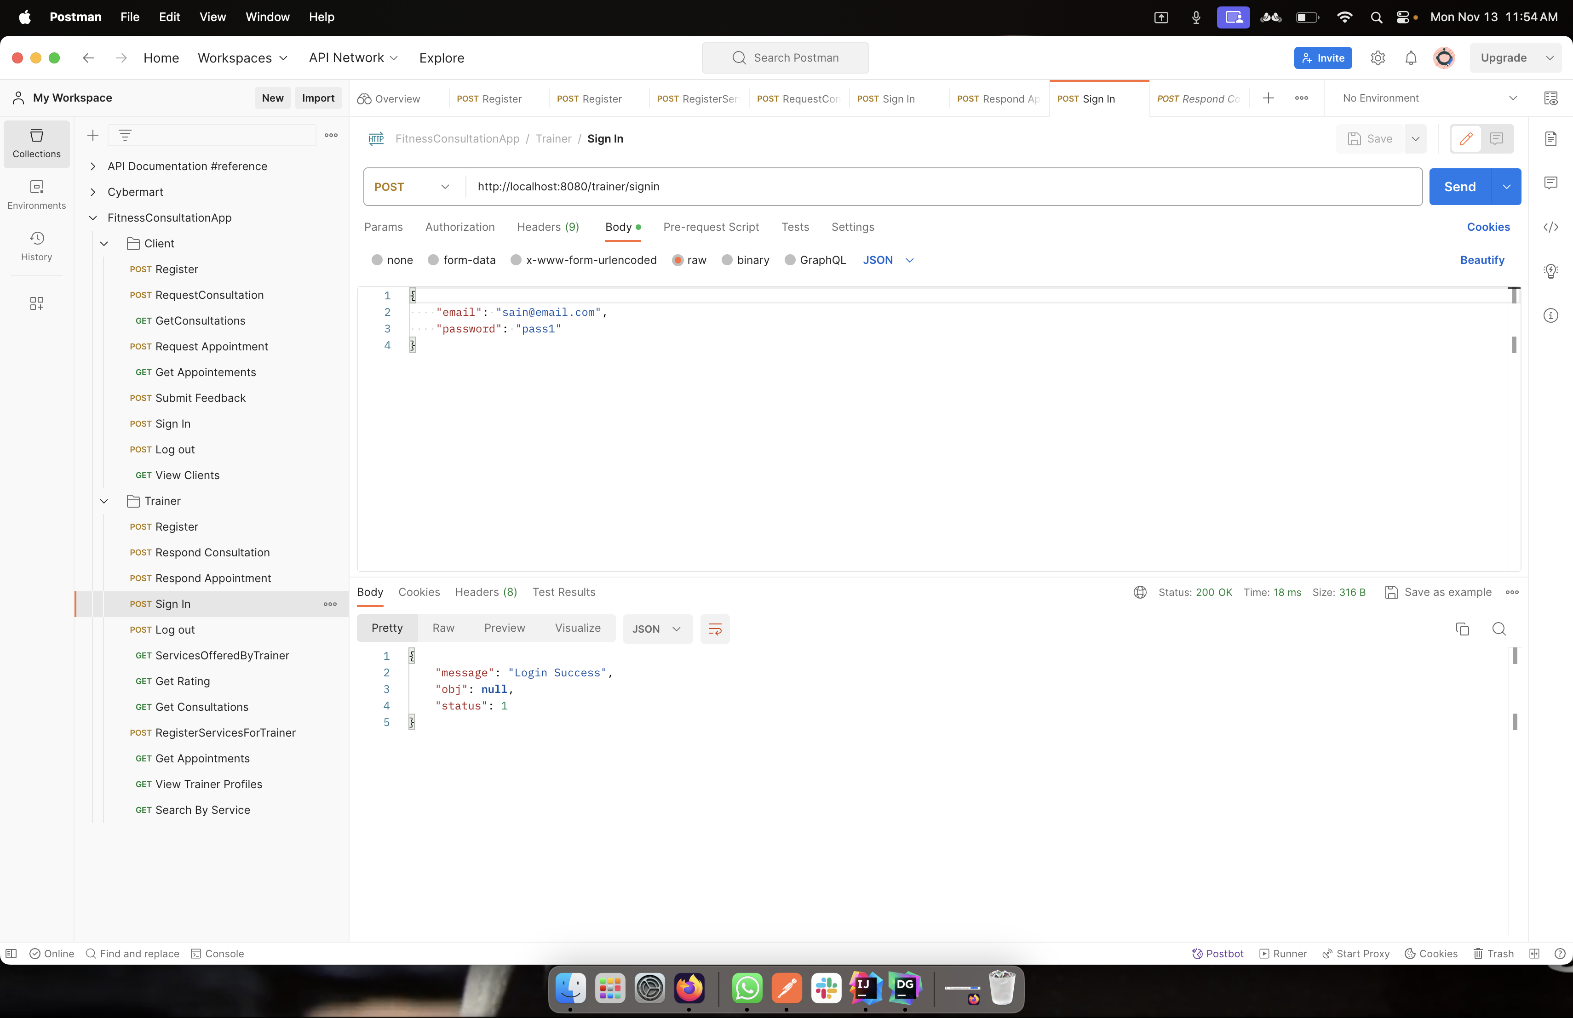

The user enters the given username and password to enter the portal. Once login details are entered correctly, the message “Login Success” appears, and session status is changed to IN.

**Method:** POST

**URL:** http://localhost:8080/trainer/signin

**Request:**

{

"email": "sain@email.com",

"password": "pass1"

}

**Response:**

* **Successful –** Status ->1

Message-> Login Success

* **Error –** Status -> 0

Message -> Incorrect Password

-> No trainer present with given emailId

**VIEW PROFILE**

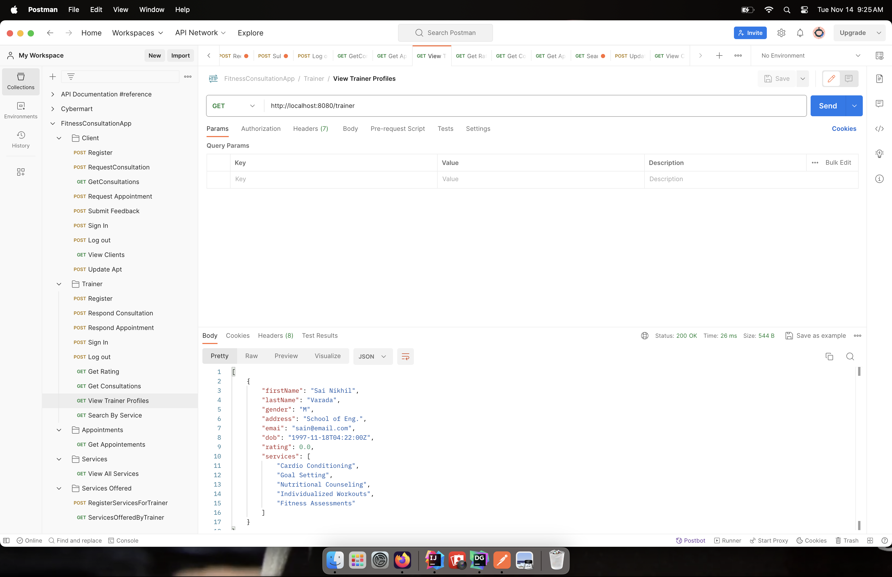

This API enables users to view their profile information. The Trainer ID is looked up in the database and all the information stored are displayed.

**Method:** GET

**URL:** http://localhost:8080/trainer

**Request:**

trainerId

format

**Response:**

* **Successful –** Status ->1

Message-> {trainer1.firstName} {trainer1.rating}

* **Error –** Status -> 0

Message -> No Closed Consultations yet

-> No Trainer present with given trainerId

-> Please provide a valid trainerId

**REGISTER FOR SERVICES**

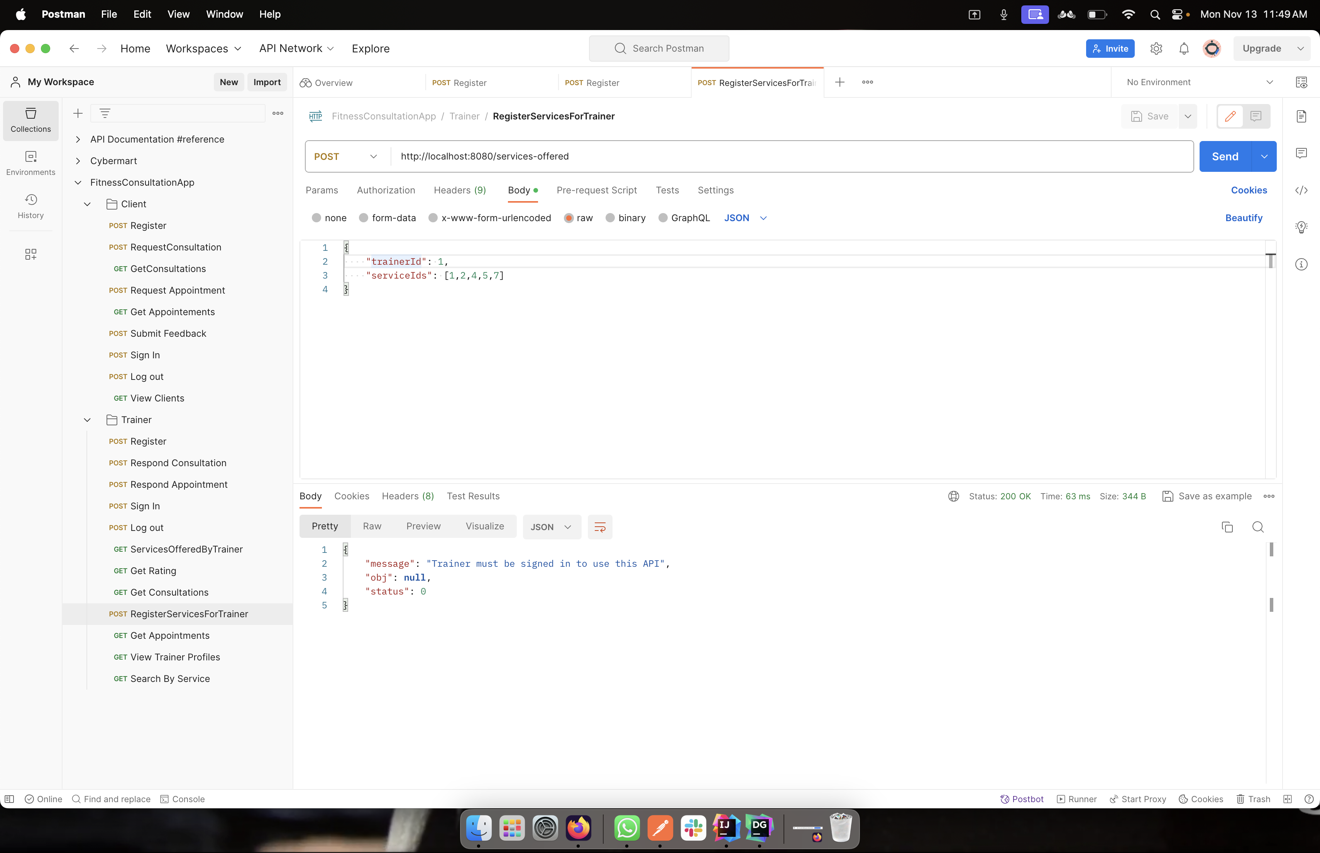

The trainers must choose the services that they are going to provide. The database has several services that is referenced with service ID. Once chosen, the service IDs of selected services are passed in. These services will be displayed to clients.

**Method:** POST

**URL:** http://localhost:8080/services-offered

**Request:**

{

"trainerId": 1,

"serviceIds": [1,2,4,5,7]

}

**Response:**

* **Successful –** Status ->1

Message-> Successfully Registered the services

* **Error –** Status -> 0

Message -> Trainer must be signed in to use this API

-> No trainer present with given trainerId

**SEARCH BY SERVICE**

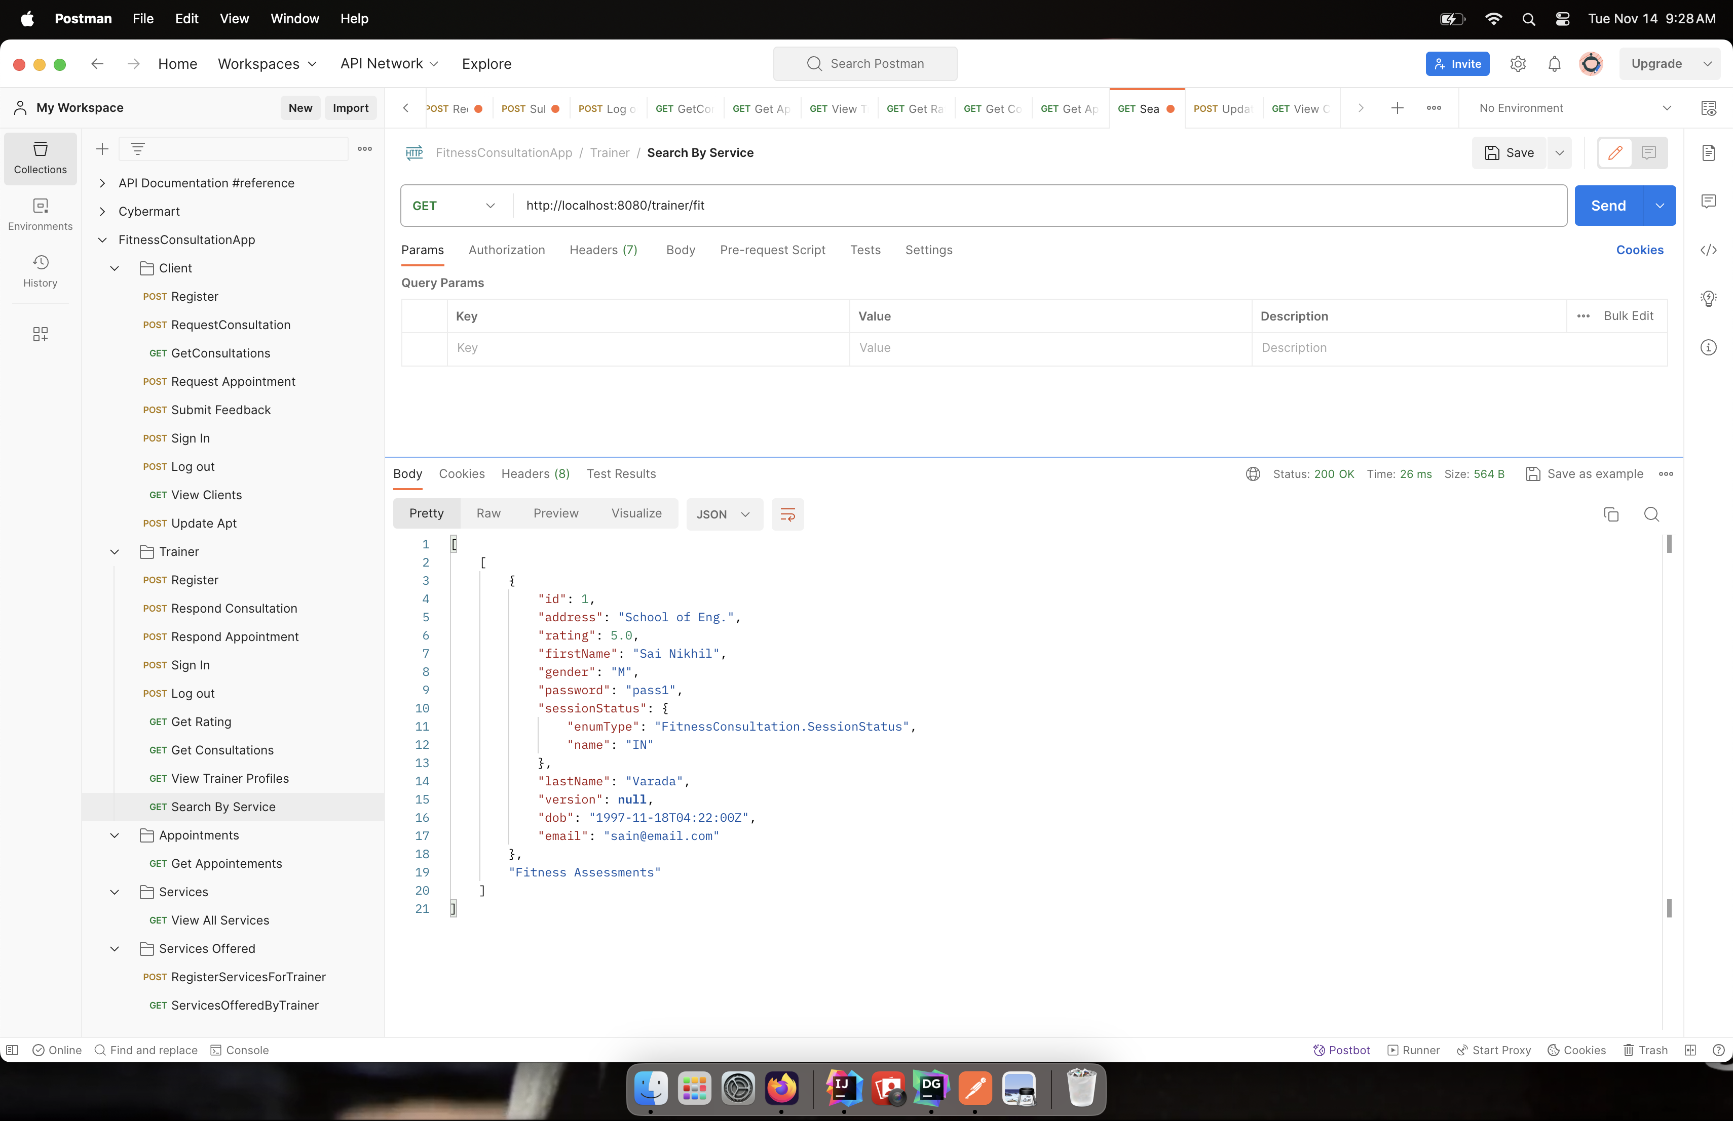

This API allows users to search for a service referencing trainers. Users can search for the service and then select the trainer offering the service.

**Method:** GET

**URL:** http://localhost:8080/trainer/fit

**Request:**

serviceID

format

**Response:**

* **Successful –** Status ->1

Message-> Registered Successfully {Trainer Id}

* **Error –** Status -> 0

Message -> No such TrainerID

**TRAINER CONSULTATION RESPONSE**

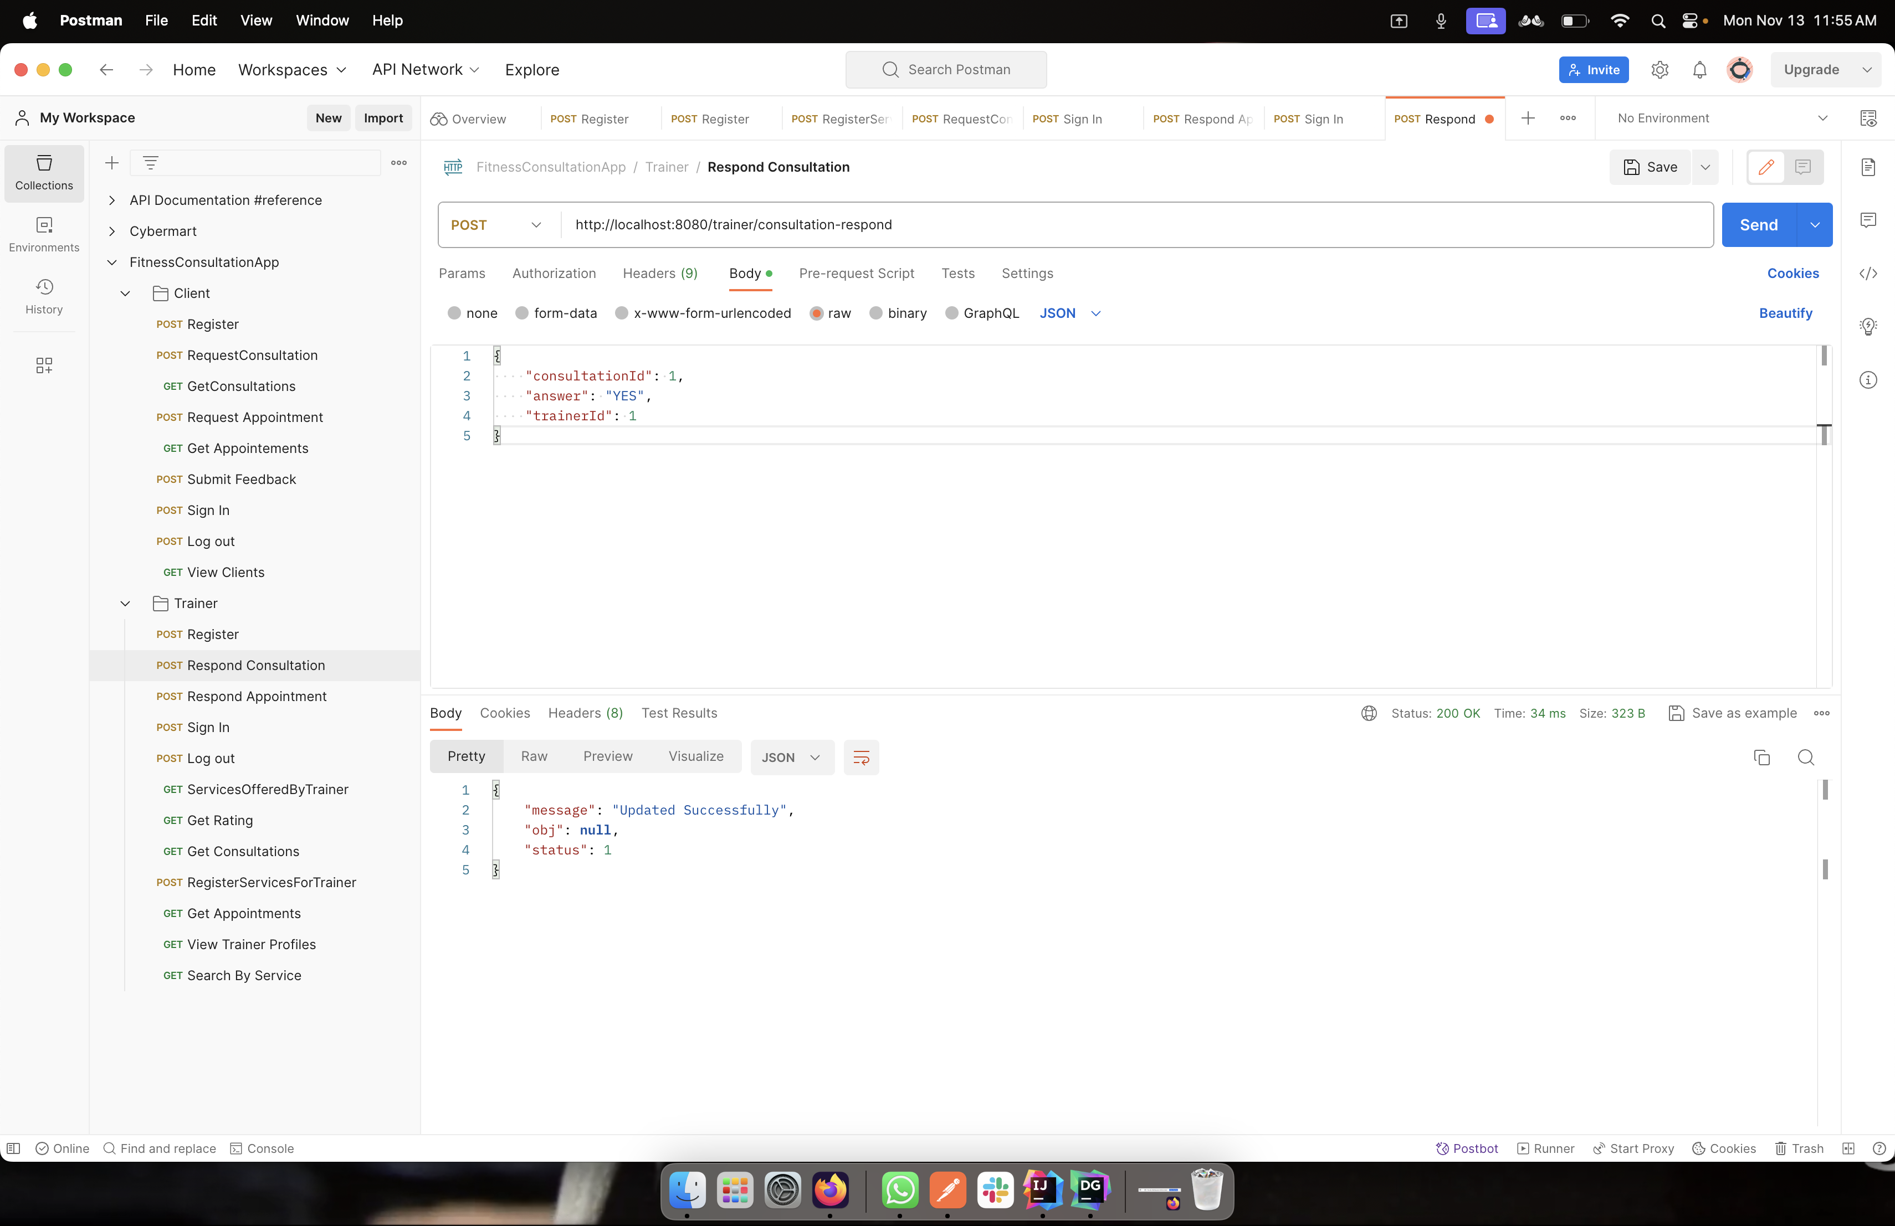

Once the client has sent a consultation request, the trainer can view and either accept or reject the request.

**Method:** POST

**URL:** http://localhost:8080/trainer/consultation-respond

**Request:**

{

"consultationId": 1,

"answer": "YES",

"trainerId": 1

}

**Response:**

* **Successful –** Status ->1

Message-> Updated Successfully

* **Error –** Status -> 0

Message -> No consultation present with given consultationId

-> Trainer must be signed in to use this API

**TRAINER APPOINTMENT RESPONSE**

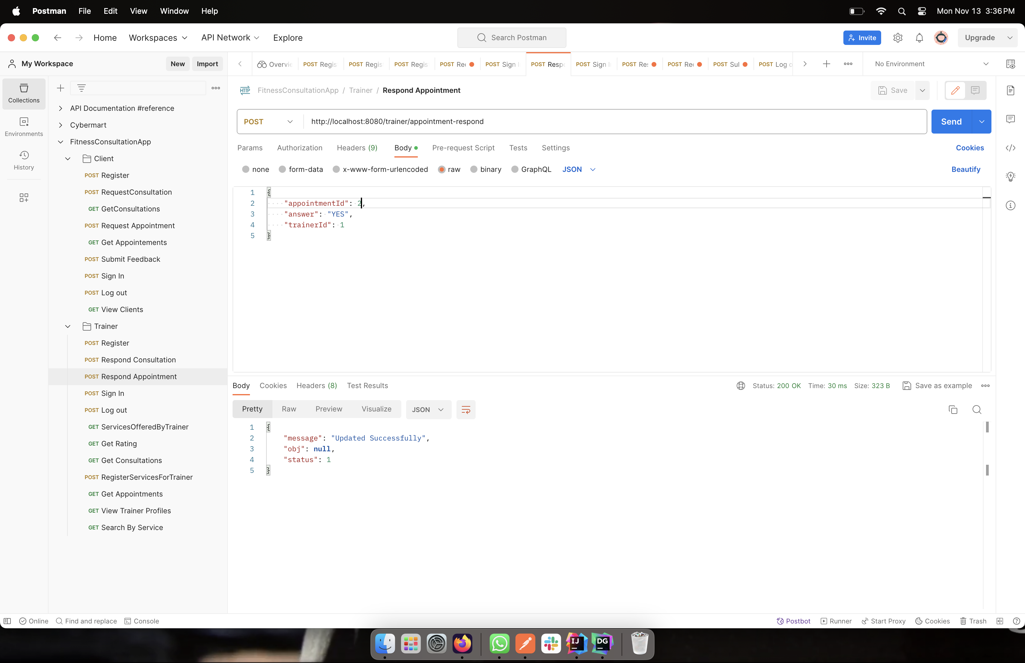

Once client sends the appointment request, the trainer can view and respond according to availability.

**Method:** POST

**URL:** http://localhost:8080/trainer/appointment-respond

**Request:**

{

"appointmentId": 2,

"answer": "YES",

"trainerId": 1

}

**Response:**

* **Successful –** Status ->1

Message-> Updated Successfully

* **Error –** Status -> 0

Message -> No appointment present with given appointmentId

-> Trainer must be signed in to use this API

**LOG OUT**

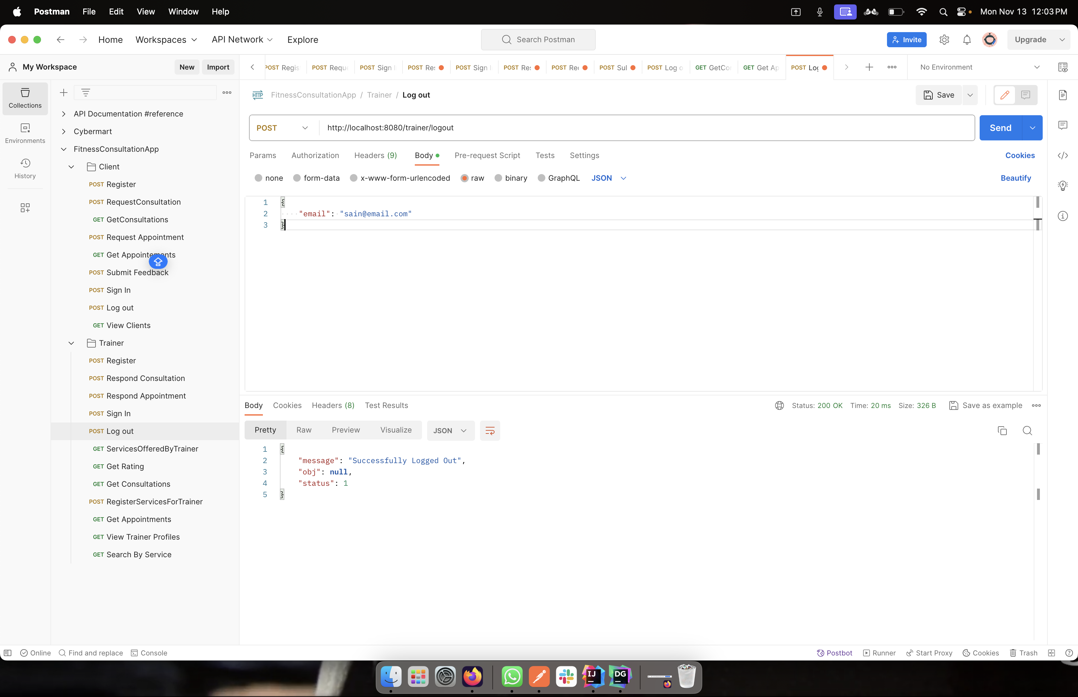

Once the services are utilized, users can logout from the systems.

**Method:** POST

**URL:** http://localhost:8080/trainer/logout

**Request:**

{

"email": "sain@email.com"

}

**Response:**

* **Successful –** Status ->1

Message-> Successfully Logged Out

* **Error –** Status -> 0

Message -> Incorrect email

-> No trainer present with given emailId

**View Appointments**

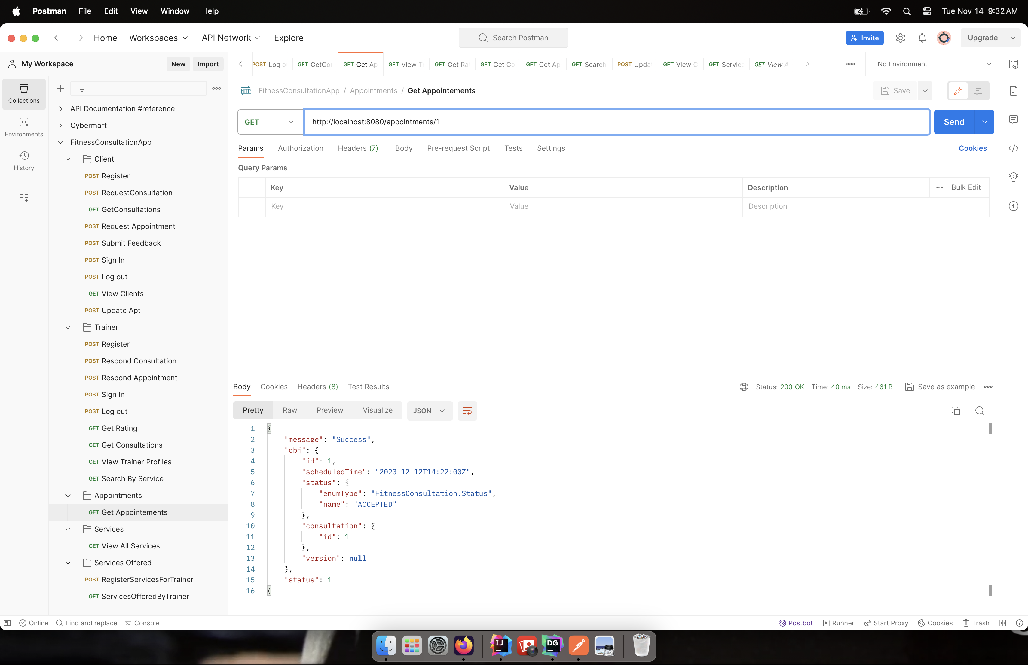

This API allows users to view the appointment details.

**Method:** GET

**URL:** http://localhost:8080/trainer/appointments/1

**Request:**

trainerID

**Response:**

* **Successful –** Status ->1

Message-> Success

* **Error –** Status -> 0

Message -> No appointments present with given trainerId

-> Provide a valid trainerId

**SERVICES**

**SERVICES OFFERED**

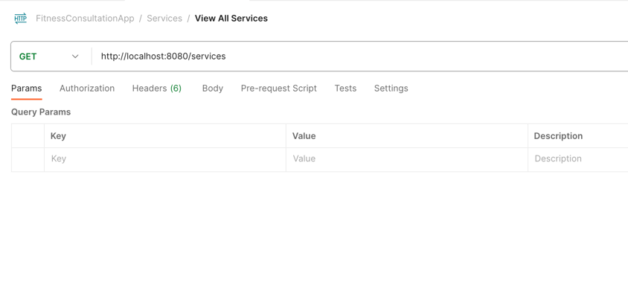

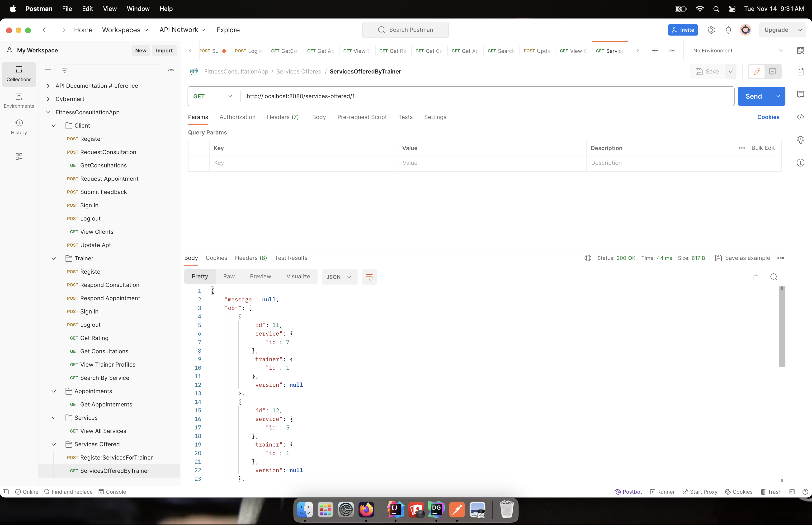

Here the services offered are displayed. Each service has a trainer ID mentioned referencing the trainer who is providing the service.

**Method:** GET

**URL:** http://localhost:8080/services

**Request:**

serviceID

**Response:**

* **Successful –** Status ->1

Message-> Services List

* **Error –** Status -> 0

Message -> No such serviceID